2.4 WIRELESS LAN
Wireless LANs can be found on college campuses, in office buildings, and in many public areas. Architecture of wired and wireless LAN
In a wireless LAN, the medium is air, the signal is generally broadcast. When hosts in a wireless LAN communicate with each other, they are sharing the same medium (multiple access).
In a wireless LAN, a host is notphysically connected to the network; it can move freely and can use the services provided by the network.

IEEE 802.11 PROJECT
IEEE has defined the specifications for a wireless LAN, called IEEE 802.11.

Architecture
The standard defines two kinds of services: the basic service set (BSS) and the extended service set (ESS).

Basic Service Set
IEEE 802.11 defines the basic service set (BSS) as the building blocks of a wireless LAN.
A basic service set is made of stationary or mobile wireless stations and an optional central base station, known as the access point (AP). The BSS without an AP is a stand-alone network and cannot send data to other BSSs. It is called an ad hoc architecture.

Extended Service Set
An extended service set (ESS) is made up of two or more BSSs with APs. In this case, the BSSs are connected through a distribution system, which is a wired or a wireless network.
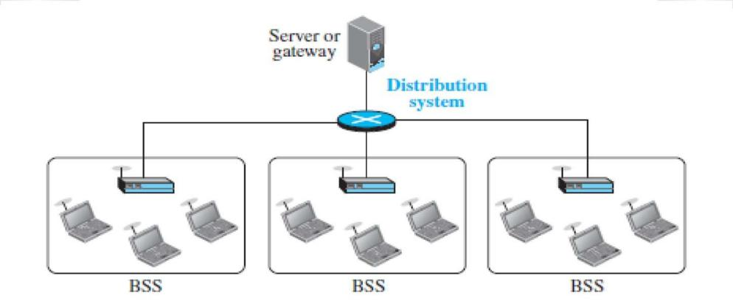
The distribution system connects the APs in the BSSs. IEEE802.11 does not restrict the distribution system; it can be any IEEE LAN such as an Ethernet. The extended service set uses two types of stations: mobile and stationary.The mobile stations are normal stations inside a BSS. The stationary stations are AP stations that are part of a wired LAN. Figure 2.4.1 shows an ESS.
Fig 2.4.1 :Extended service set.

Station Types – Three stations
A station with no-transition mobility is either stationary (not moving) or moving only inside a BSS. A station with BSS-transition mobility can move from one BSS to another, but the movement is confined inside one ESS. A station with ESS-transition mobility can move from one ESS to another. MAC Sublayer
IEEE 802.11 defines two MAC sublayers: the distributed coordination function (DCF) and point coordination function (PCF).Figure 2.4.2 shows the relationship between the two MAC sublayers, the LLC sublayer, and the physical layer.
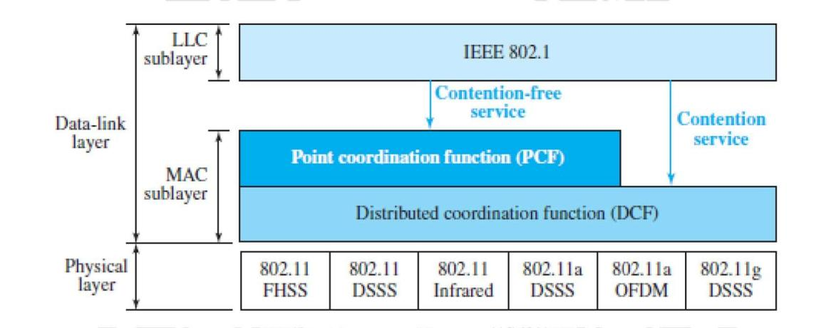
Fig 2.4.2:MAC layers.
[Source : “Data Communications and Networking” by Behrouz A. Forouzan,Page-442]

Distributed Coordination Function
One of the two protocols defined by IEEE at the MAC sublayer is called the distributed coordination function (DCF). DCF uses CSMA/CA as the access method.
Figure 2.4.3 shows the exchange of data and control frames in time.
- Before sending a frame, the source station senses the medium by checking the energy level at the carrier frequency.The channel uses a persistence strategy with back off until the channel is idle.After the station is found to be idle, the station waits for a period of time called the distributed inter frame space (DIFS); then the station sends a control frame called the request to send (RTS).
- After receiving the RTS and waiting a period of time called the short inter frame space (SIFS), the destination station sends a control frame, called the clear to send (CTS), to the source station.
This control frame indicates that the destination station is ready to receive data.The source station sends data after waiting an amount of time equal to SIFS.The destination station, after waiting an amount of time equal to SIFS, sends an acknowledgment to show that the frame has been received.

When a station sends an RTS frame, it includes the duration of time that it needs to occupy the channel. The stations that are affected by this transmission create a timer called a network allocation vector (NAV) that shows how much time must pass before these stations are allowed to check the channel for idleness. Each time a station accesses the system and sends an RTS frame, other stations start their NAV.

Hidden-Station Problem
The solution to the hidden station problem is the use of the handshake frames (RTS andCTS). Figure 2.4.3 shows that the RTS message from B reaches A, but not C. However,because both B and C are within the range of A, the CTS message, which contains the duration of data transmission from B to A, reaches C. Station C knows that some hidden station is using the channel and wait for some time from transmitting until that duration is over.
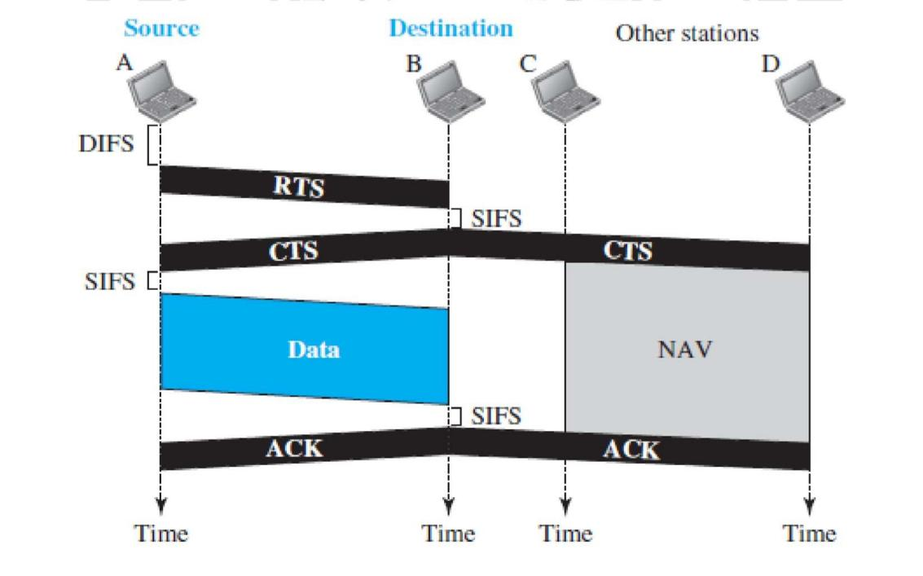
Fig 2.4.3:Hidden station problem.
[Source : “Data Communications and Networking” by Behrouz A. Forouzan,Page-442]

Frame Format
The MAC layer frame consists of nine fields as in figure 2.4.4.

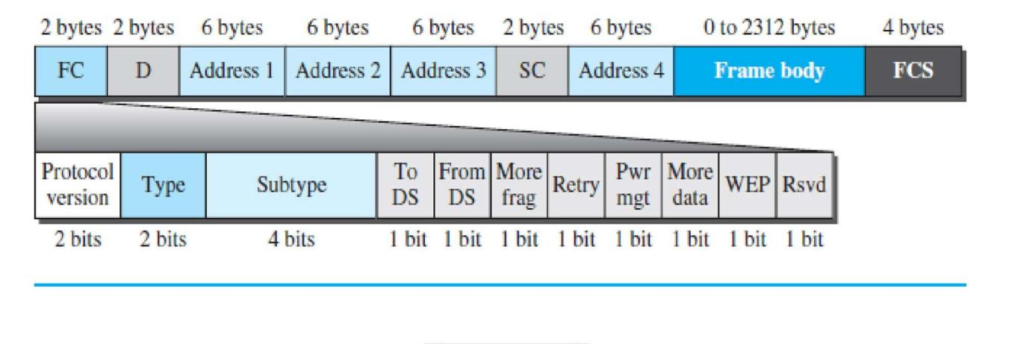
Fig2.4.4: MAC layer frame.
[Source : “Data Communications and Networking” by Behrouz A. Forouzan,Page-444]

Frame control (FC). The FC field is 2 bytes long and defines the type of frame and some control information.
D. This field defines the duration of the transmission that is used to set the value of NAV. In one control frame, it defines the ID of the frame.
Addresses.There are four address fields, each 6 bytes long. The meaning of eac h address field depends on the value of the To DS and From DS subfields and will be discussed later.
Sequence control.This field, often called the SC field, defines a 16-bit value.
The first four bits define the fragment number; the last 12 bits define the sequence number, which is the same in all fragments.
Frame body. This field, which can be between 0 and 2312 bytes, contains information based on the type and the subtype defined in the FC field.
FCS.The FCS field is 4 bytes long and contains a CRC-32 error-detection sequence.

Frame Types
A wireless LAN defined by IEEE 802.11 has three categories of frames: Management frames, control frames, and data frames.
Management Frames: Management frames are used for the initial communication between stations and access points.
Control Frames: Control frames are used for accessing the channel and acknowledging frames. Figure2.4.5 shows the format.
Data Frames:Data frames are used for carrying data and control information.

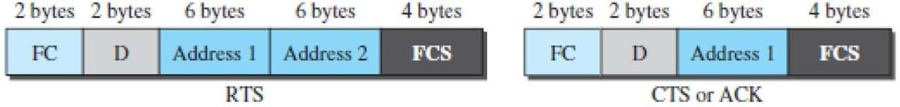

Fig2.4.5:Control frames.
[Source : “Data Communications and Networking” by Behrouz A. Forouzan,Page-446]

Addressing Mechanism
The IEEE 802.11 addressing mechanism specifies four cases, defined by the value of the two flags in the FC field, To DS and From DS.
Each flag can be either 0 or 1, resulting in four different situations. Address 1 is always the address of the next device that the frame will visit.
Address 2 is always the address of the previous device that the frame has left. Address 3is the address of the final destination station if it is not defined by address 1 or the original source station if it is not defined by address 2.
Address 4 is the original source when the distribution system is also wireless.

DS- Distributed system
Case 1: 00 In this case, To DS =0 and From DS =0. This means that the frame is not going to a distribution system (To DS =0) and is not coming from a distribution system (From DS =0).
The frame is going from one station in a BSS toanother without passing through the distribution system.
Case 2: 01 In this case, To DS =0 and From DS =1. This means that the frame is coming from a distribution system (From DS =1). The frame is coming from an AP and going to a station.
Note that address 3 contains the original sender of the frame (in another BSS).
Case 3: 10 In this case, To DS =1 and From DS =0. This means that the frame is going to a distribution system (To DS=1). The frame is going from a station to an AP. The ACK is sent to the original station.
Note that address 3 contains the final destination of the frame in the distribution system.
Case 4: 11 In this case, To DS =1 and From DS =1. This is the case in which the distribution system is also wireless. The frame is going from one AP to another AP in a wireless distribution system. Here, we need four addresses to define the original sender, the final destination, and two intermediate APs.

Exposed Station Problem
In this problem a station refrains from using a channel when it is, available.
In Figure 2.4.6 , station A is transmitting to station B. Station C has some data to send to station D, which can be sent without interfering with the transmission from A to B.
Here, station C is exposed to transmission from A; it hears what A is sending and thus refrains from sending. In other words, C is too conservative and wastes the capacity of the channel.
The handshaking messages RTS and CTS cannot help in this case.
Station C hears the RTS from A and refrains from sending, eventhough the communication between C and D cannot cause a collision in the zone between A and C; station C cannot know that station A’s transmission does not affect the zone between C and D.
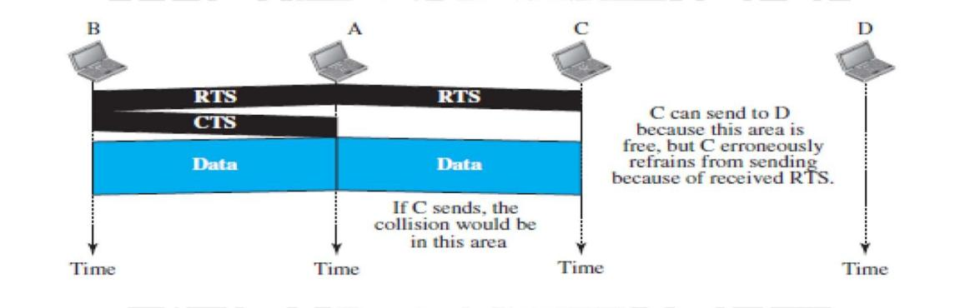
Fig 2.4.6: Exposed Station Problem.
[Source : “Data Communications and Networking” by Behrouz A. Forouzan,Page-448]

………………………………………………………………………………..

